|  |  |
| --- | --- |
| Power BI Lab Day 7 Document | |
|  |  | | |
| **Writer:** | I&D Microsoft | | **Initials entity:** |
| **Date creation:** 24/04/2018 | |  | **Last upgrade:** 25/04/2018 |

Power BI LAB DOCUMENT

DAY 7- Lab 1 – What IF ANALYSIS

|  |  |  |  |  |
| --- | --- | --- | --- | --- |
| Version | Author | Comment | Reviewed By | Date |
| V 1.0 | I&D Microsoft | Initial draft | Moupiya Das |  |
|  |  |  |  |  |
|  |  |  |  |  |

# Table of Contents

Table of Contents 2

1. Import Data 3  
2. Data Modelling 4  
3. Data Visualization 6

**Pre-requisites**

Installed and working Power BI Desktop setup.

We go through life, day in and day out, asking ourselves “What if?”…….Today’s Power BI adventure is just about that. In August 2017, Microsoft released this wonderful functionality which enable users to quickly create multiple variables to be used as part of their “what if analysis”. The possibilities with this is literally endless, giving users and businesses from various different backgrounds the flexibility to design a solution which will give them the answers and insight they so desperately need.

To showcase this functionality we’re going to create a simple demonstration (using the ‘What if Parameters’ of course) to create a Sales Discount Calculator. This will help give users a basic idea of how ‘What if Parameters’ can be used within the Power BI Desktop application.

Let’s get started….

# 1. Import Data

1. Start with a blank Power BI Desktop file. Click on Get Data option in the ‘**Home**’ tab.

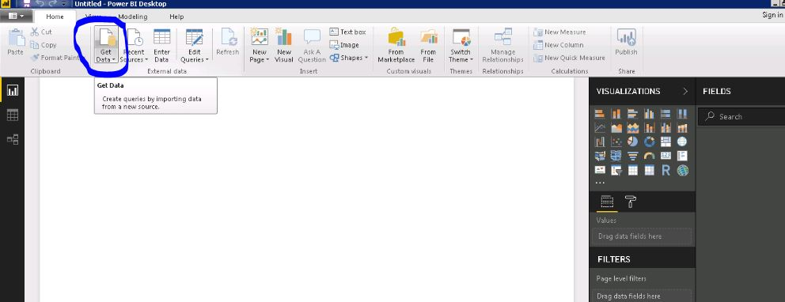  
  
Connect using excel as a data source. Use AdventureWorksdatabase.xlsx. Choose the below highlighted files.

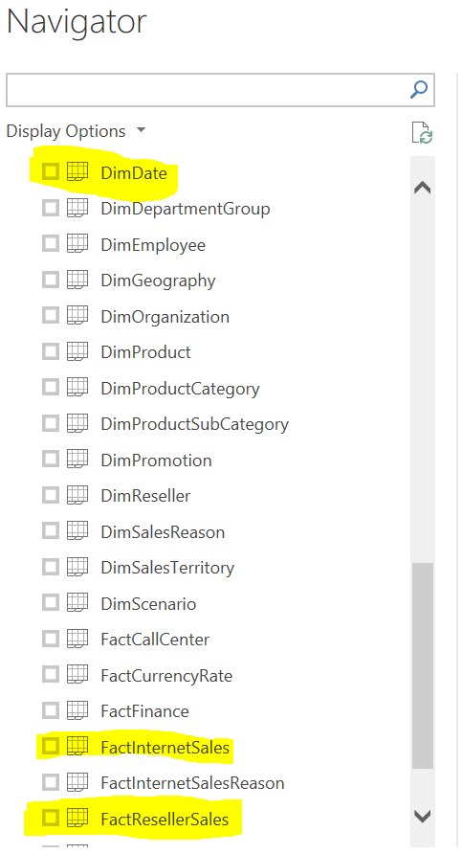

# 2. Data Modelling

1. In Edit Query, Duplicate **DateKey** Column of table **DimDate** and change datatype to whole number. Click ‘**Close and Apply**’.

2. Go to modelling tab and create relationship between the date fields of the Fact table and the Date field of the Dimension table using **Manage Relationships**.

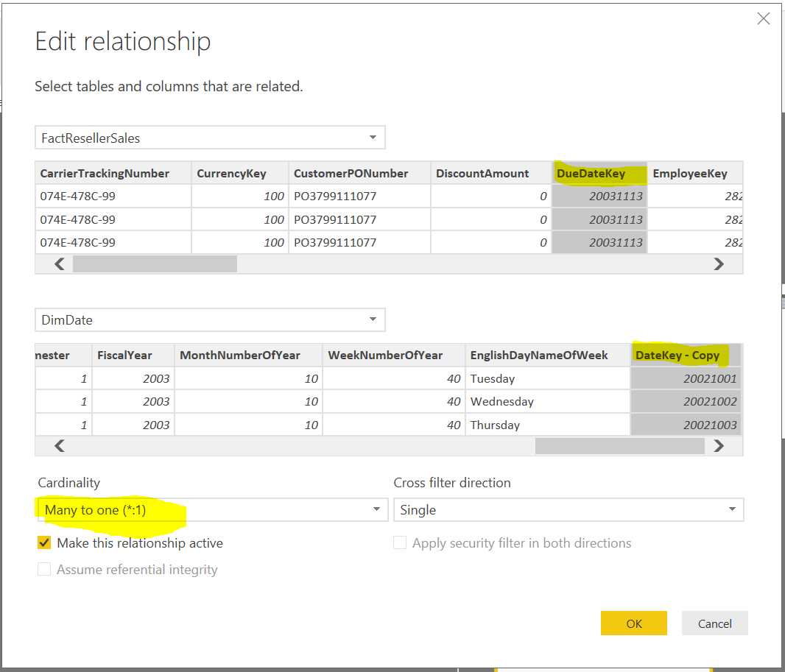

1. Go to Modelling tab and select **New Parameter**:

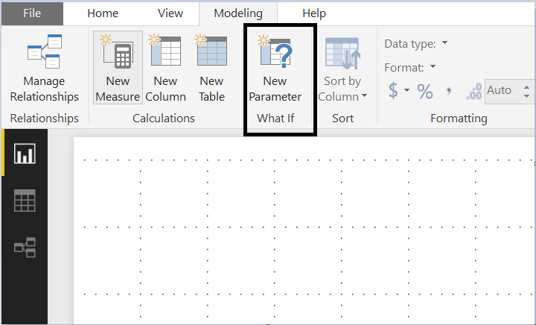

Update the parameters as shown below and save. This will create a new table in the model.

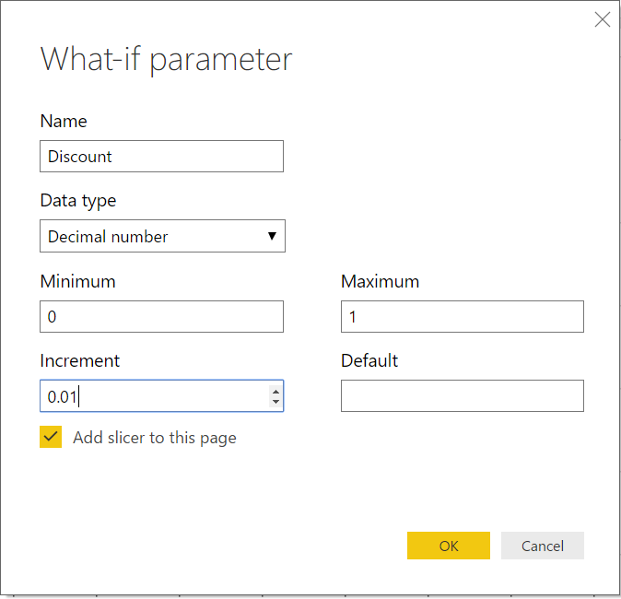

1. Rename the fields in the new table created in the model.

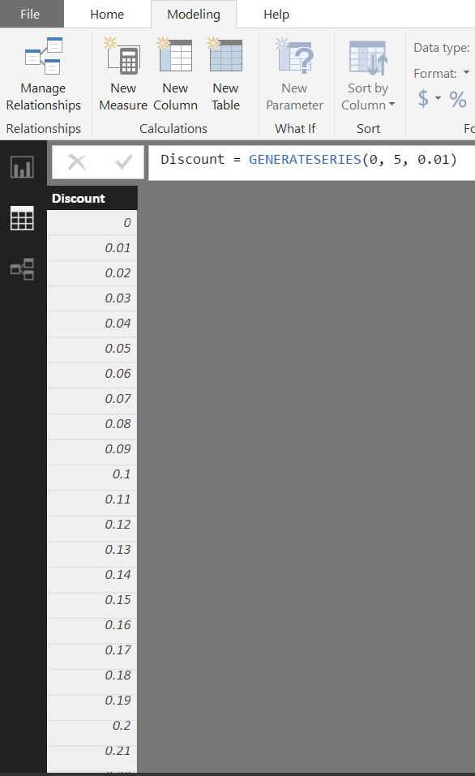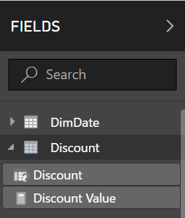

6. Add a new measure to the FactReseller table - **DiscountSales** = SUM(FactResellerSales[SalesAmount]) - (SUM(FactResellerSales[SalesAmount]) * Discount[Discount Value])

# 3. Data Visualization

Take a table visual and drag the **CalendarYear** and **EnglishMonthName** from the Dim table and **SalesAmount and DiscountSales** from the Fact table:

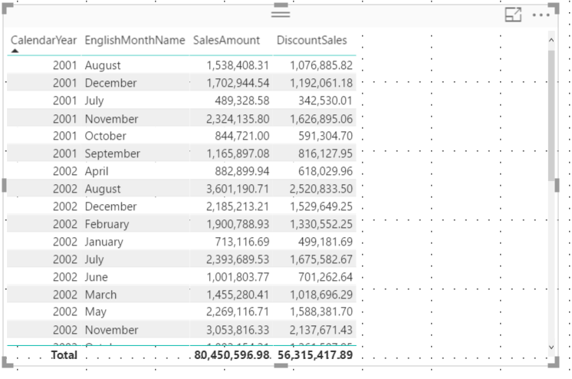

Change the slider and see the impact in the DiscountSales column.

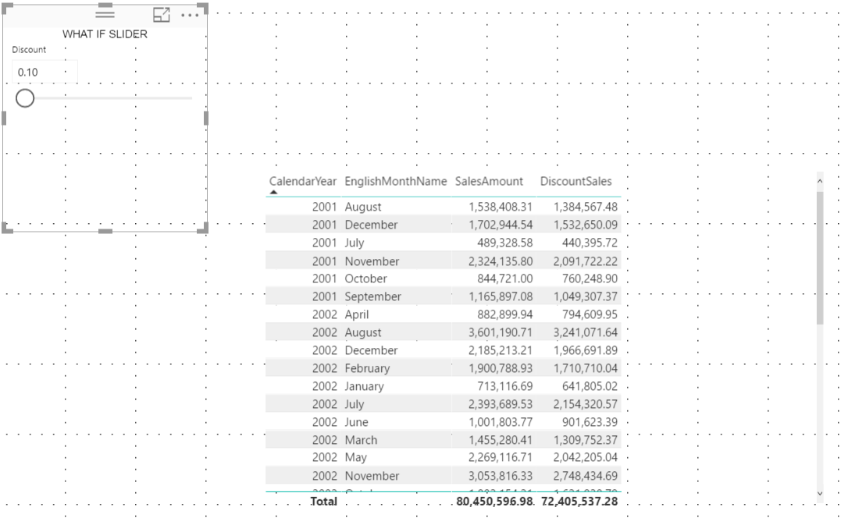

Notice the dynamic text we entered change based on your selection.